**M.I.T. LAB Assignment – 02**

**U19CS012**

(1) Write a program for one’s complement of 8-bit number.

Notepad Code:

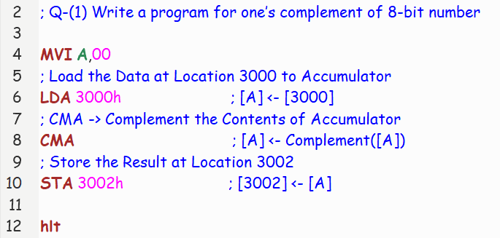

Registers and Memory:

Eg: (1) Let A = 00H = (0000 0000)2 = 0 => A’ = FFH = (1111 1111)2 = 255

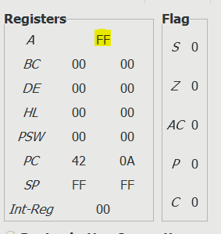 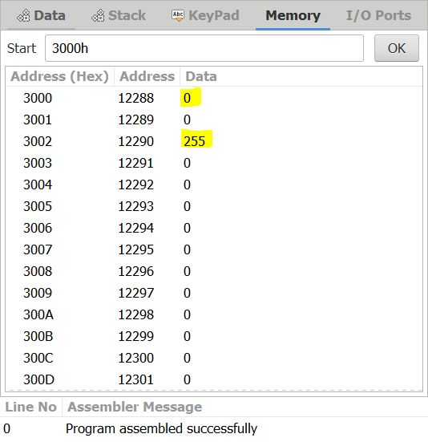

Eg: (2) Let A = 96H = (1001 0110)2 = 150 => A’ = 69H = (0110 1001)2 = 105

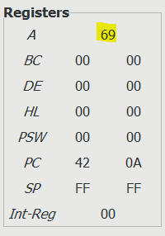 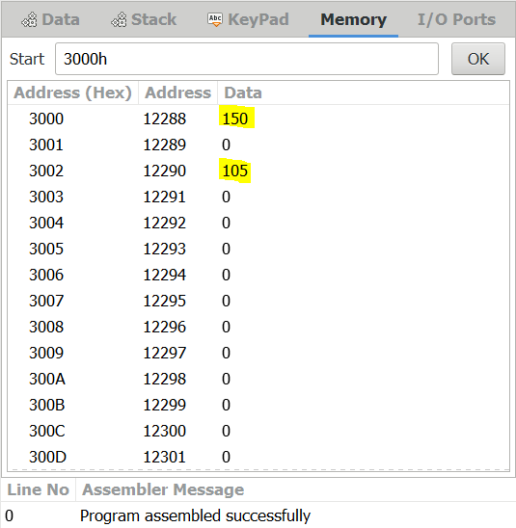

(2) Write a program for two’s complement of 8-bit number.

Notepad Code:

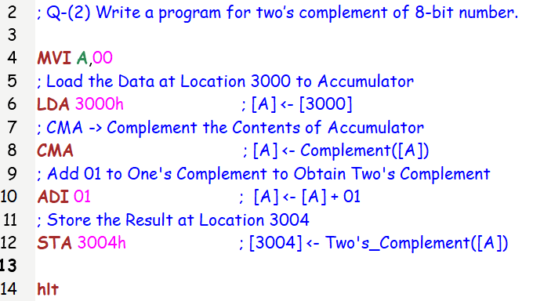

Registers and Memory:

Eg: (1) Let A = 01H = (0000 0001)2 = 1 => A’ + 1 = FFH = (1111 1111)2 = 255

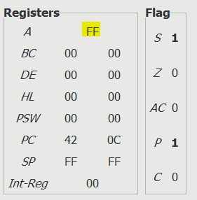 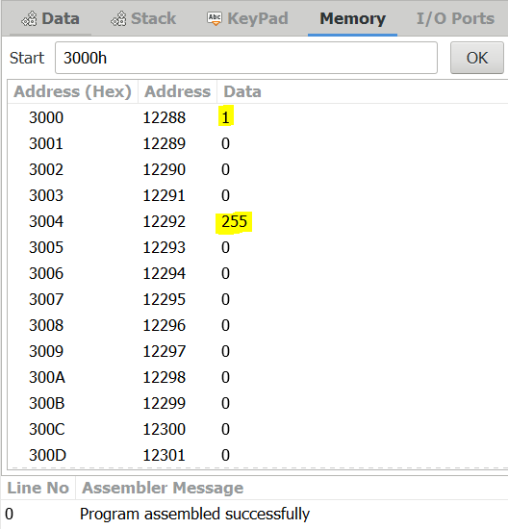

Eg: (2) Let A = 96H = (1001 0110)2 = 150 => A’ + 1 = 6AH = (0110 1010)2 = 106

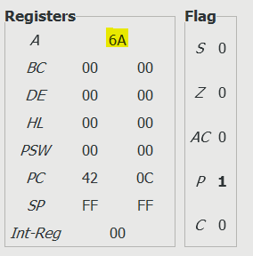 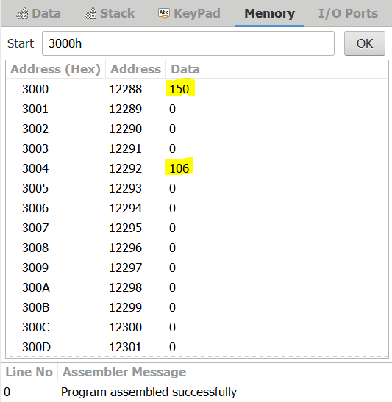

(3) Write an assembly language program that AND, OR and XOR together the contents of register B, C and E and place the result into memory location 3000H, 3001H and 3002H.

Notepad Code:

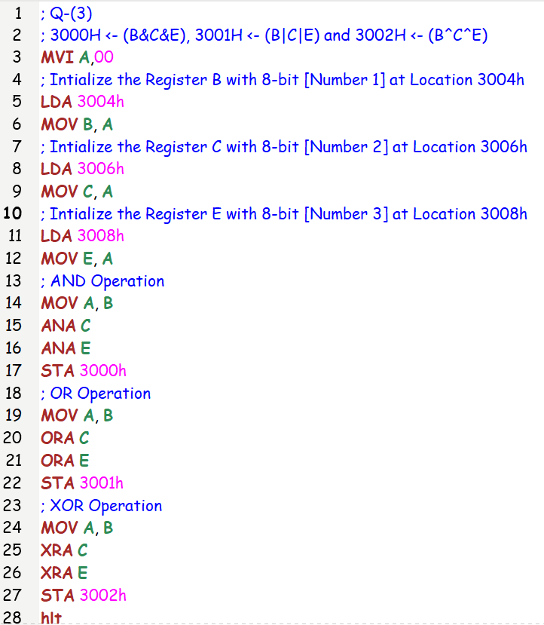

Registers and Memory:

Eg: (1) Let

B = 96H = (1001 0110)2 = 150

C = ACH = (1010 1100)2 = 172

E = D2H = (1101 0010)2 = 210

AND = (80)H = (1000 0000)2 = 128

OR = (FE)H = (1111 1110)2 = 254

XOR = (E8)H = (1110 1000)2 = 232

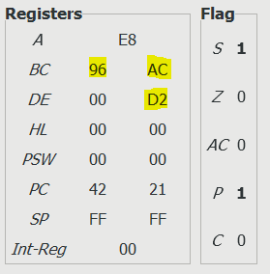 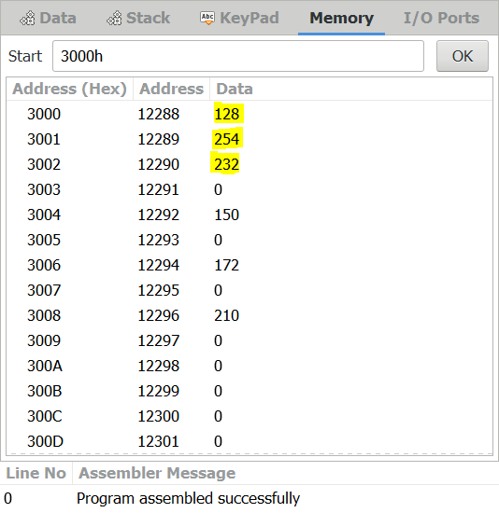

(4) Write a program to shift 8-bit no by three bits left. Assume data

is in register C.

Notepad Code:

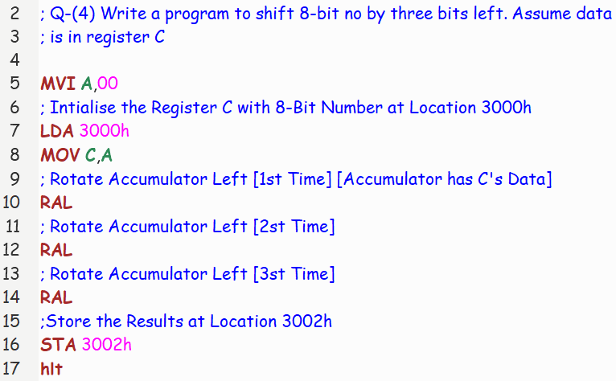

Registers and Memory:

Eg: (1) Let C = 05H = (0000 0101)2 = 5

Shift Left 1st Time = (0000 1010)2 = 10

Shift Left 2nd Time = (0001 0100)2 = 20

Shift Left 3rd Time = (0010 1000)2= 40 = 28H

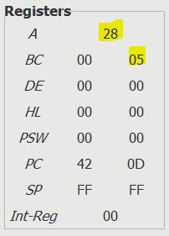 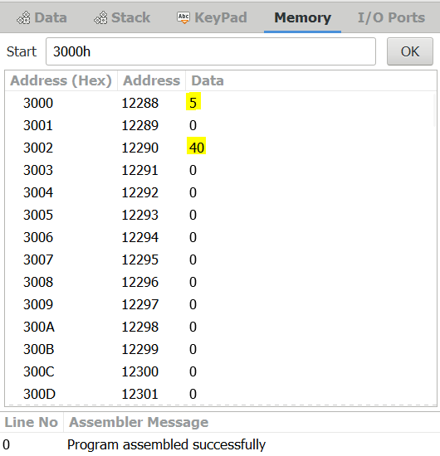

(5) Write a program to shift 8-bit data four bits right. Assume data

is present in register C.

Notepad Code:

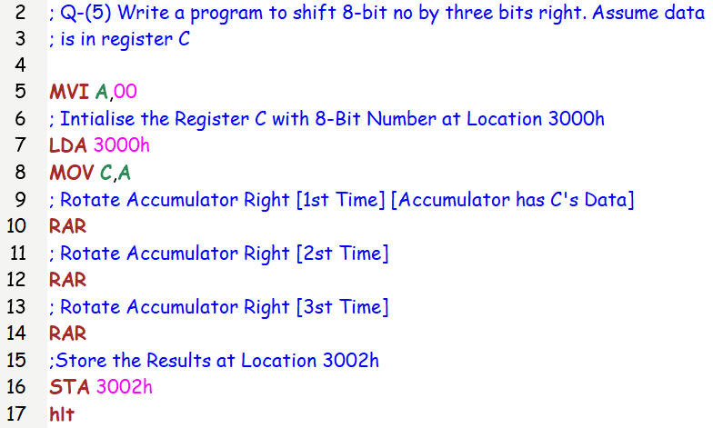

Registers and Memory:

Eg: (1) Let B = 05H = (0100 0000)2 = 64 = 40H

Shift Right 1st Time = (0010 0000)2 = 32

Shift Right 2nd Time = (0001 0000)2 = 16

Shift Right 3rd Time = (0000 1000)2= 8 = 08H

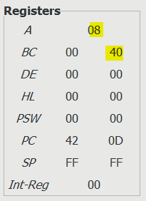 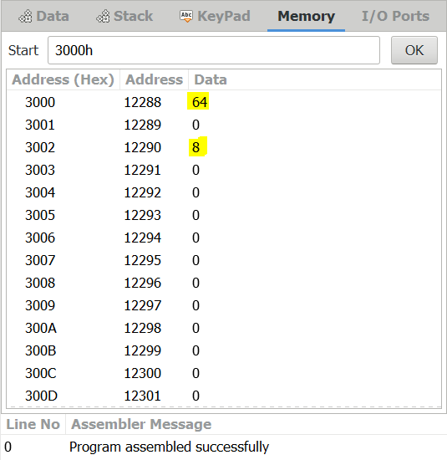

(6) Write a Program to Multiply Two 8-bit Numbers. [Using **Repeated Addition** Method]

Notepad Code:

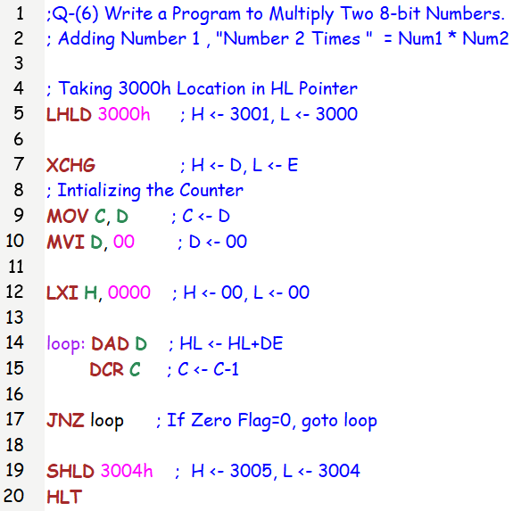

Input:

Number 1 [3000H] = 15 = (0F)H

Number 2 [3001H] = 12 = (0C)H = Counter

Output:

Output 16 Bit Answer = Register Pair Form: [3005H-3004H] = (00 B4)H = 180

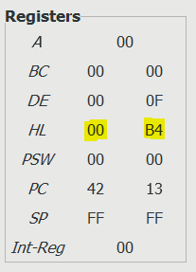 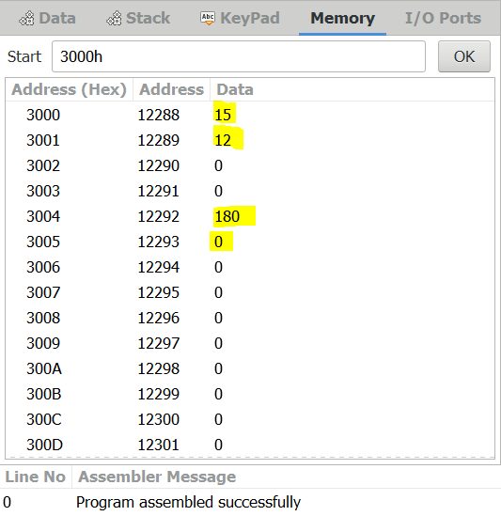

Input:

Number 1 [3000H] = 15 = (0F)H

Number 2 [3001H] = 19 = (13)H = Counter

Output:

Output 16 Bit Answer = Register Pair Form: [3005H-3004H] = (01 : 29) = (01 1D)H = 285

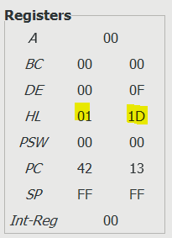 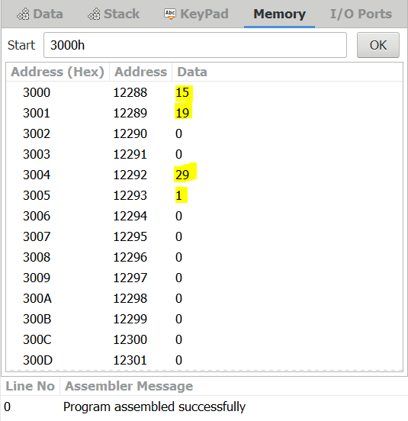

(7) Write a Program to find Largest of two 8-bit numbers.

Notepad Code:

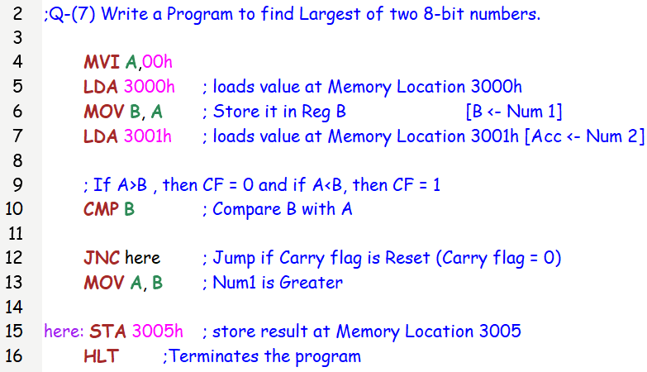

Registers and Memory: Input: 5 & 10 Output: 10 [Since 10>5]

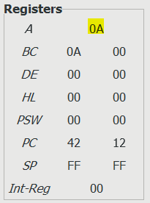 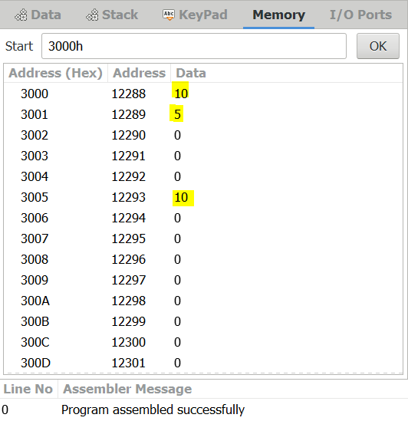

SUBMITTED BY: BHAGYA VINOD RANA [***U19CS012***]